West Lothian 50+ Network
Minutes of Members Meeting – 18th September 2021

- Convenor Anne Webster welcomed everyone to the first meeting for 18 months. A special welcome was made to new members attending for the first time. Anne explained that some of the Committee members were unable to attend but they sent their best wishes and hoped to be at next month’s meeting.

- Anne introduced the speaker, Carmen, who gave an interesting talk about Tai Chi and the differences between Qigong and Tai Chi. This was followed by a demonstration by three members of her class. They have been doing Tai Chi for two years and gave a very graceful performance. Carmen then demonstrated 24 forms of the “fan” movement.

- The latest new staff member, Fiona Cochrane, was then introduced to the members. Fiona is responsible for ensuring that we comply with all the Covid regulations and is the person to contact if members have any questions. She is also responsible for managing the Hub.

- It was decided to restart the raffle in October. Members were quite happy with this.

- After the tea and coffee break the members were advised that several new groups have started up. An up to date list of all the groups can be seen in the Hub.

- Trips and Holidays. A brief outline of up -coming trips and holidays was given and members were advised that the Hub Coordinators would be happy to supply any further information required.

- Coach Trips. It has been decided by Heather and Sue that some of the coach trips will be on a Saturday especially in the winter as shops and venues are so often closed on Sundays in some of the places visited. The pick up point has also moved from the Old railway station to the New railway station as parking is easier there. Please check the pick up point and the day of the trip you are going on.

Trips

Day trip to Kelburn Castle and Estate and Largs
Date: Sunday 26th September.
Closed for bookings
Pick up - Old Railway Station Bathgate
Depart 9.30am and return at 6pm

Dunkeld Walking Trip.
Date: Saturday 6th October
Fully Booked
Pick up – New Railway station, Bathgate
Depart 9.30am and return 5.30pm

Autumn in the Trossachs and Perthshire.
Date: Saturday 30th October
Fully Booked
Trip will visit Killin, Kenmore and Dunkeld. Please note that this is a Saturday trip and transport is provided by Golden Eagle coaches.
Pick up – New Railway Station, Bathgate
Depart at 9.30am and return at 5.25pm

HOLIDAYS
Isle of Skye and Plockton Cruise
Date: Monday 11th to Friday 15th April 2022
Deposit of £30 payable to the Hub from Wednesday 29th September 2021
Balance £335 payable to the Hub by Friday 25th February, 2022
Total cost: £365 per person.
5 days/4 nights
A truly unique holiday to the magical Isle of Skye. Enjoy 4 nights staying on the Isle of Sky in the Kings Arms Hotel. This peaceful location is the perfect base for exploring – with our day excursions to Portree and a full day tour of Skye and a visit to Plockton and Eilean Donan Castle, Scotland’s most photographed castle.
Holiday includes:
4 nights Dinner, bed and breakfast
Luxury Coach Travel
Excursions as shown above.
Evening entertainment
Porterage

Further details on excursions available from the Hub

The Enchanted Forest. In Pitlochry. Please note your interest by 29th September. No payment is necessary yet. Booking will only open once notes of interest have been received.

Date: October 2022
Cost: £39

As the 2021 event will not happen West Lothian 50+ Network would like to gauge interest in a trip to the Enchanted Forest, Pitlochry in October 2022.
The price of £39 includes coach transport and admission to the Enchanted Forest. There may be the option of High Tea at Fishers Hotel at an additional cost.

- HUB
- The Hub is now fully open to members from 10.00am to 2.00pm Monday to Friday
- There is a variety of jigsaws, books and handmade cards available in the Hub. Anyone with jigsaws they wish to donate should hand them into the Hub.

- New Premises
A 10 year lease has been signed with a 5 year break for new premises at 14 George Street – previously the Santander Bank. Necessary work is being carried out to bring the premises up to 50+ requirements. Some of the Group Leaders visited the premises last week and more will be visiting next week. Due to the difficulty of getting tradespeople to do necessary work, it is difficult to give an exact opening date. It is hoped, however, that it will be opened by January next year. Members were informed that the old office will not be kept.

- AOCB
Opal are holding a Mates and meals evening on 12th October from 6-8pm.

- Next Meeting
The next meeting is Saturday 16th October 2021. The speaker in October will be Jim Allan, West Lothian Litter Pickers who will talk about their origins, work, links with West Lothian Council.

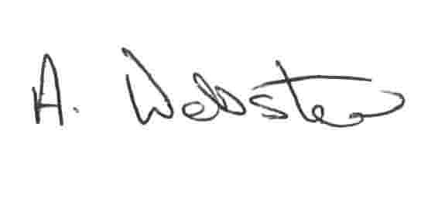

Anne Webster - Convenor
West Lothian 50+ Network

